**Softwares :**

* Microsoft Visual Studio 2015 (for Desktop App)
* Android studio 2.3.2 (for Android App)
* Microsoft SQL server (for database) <https://www.microsoft.com/en-in/sql-server/sql-server-downloads>

**Software Installation Requirements :**

* Microsoft SQL Server Management Studio 2017 needs to be downloaded after Microsoft SQL server is installed.

**Desktop Application :**

* Connection String needs to be changes on every page of the database.

String cs=’your database string here’;

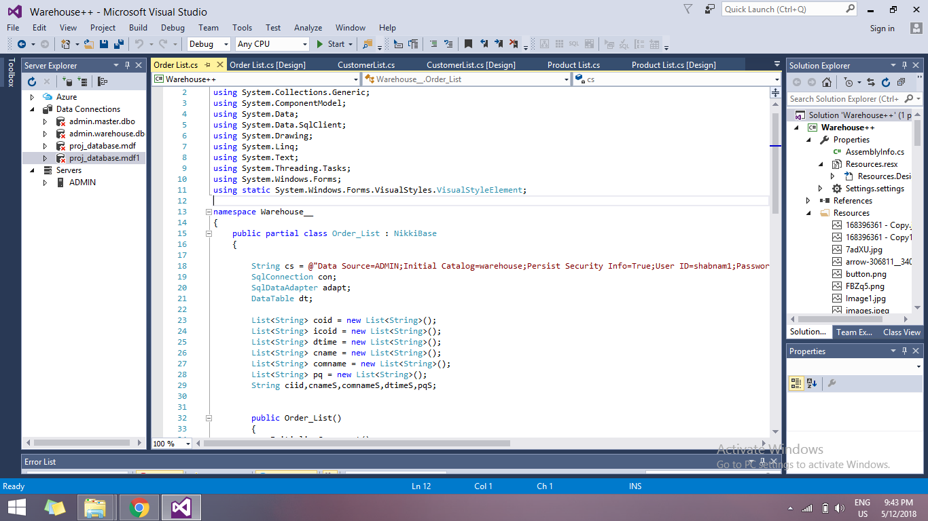

* Steps to add Database from SSMO to Visual Studio Project.

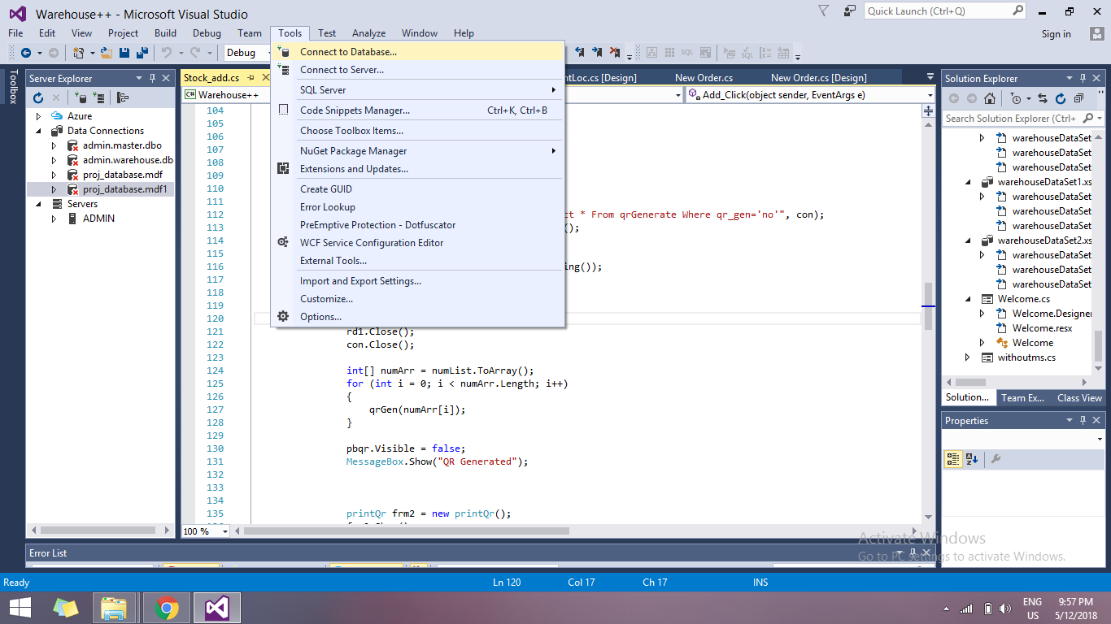

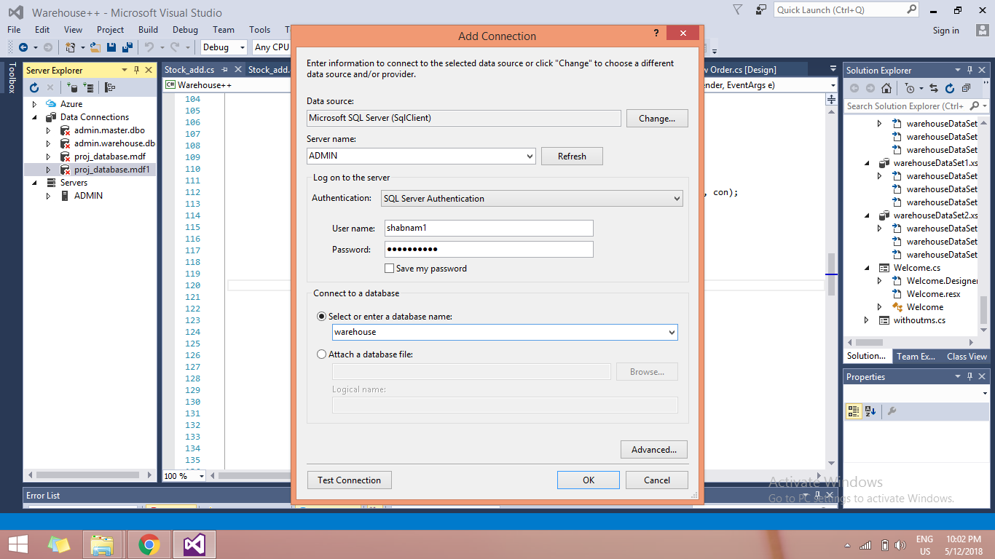

1. Data Source : Microsoft SQL Server (SqlClient)
2. Server Name : As in the SSMO Login
3. Authentication : SQL Server Authentication
4. Username & Password : As in the SSMO Login
5. Select or enter a Database : Database Name

Test the connection and if successful, click ok.

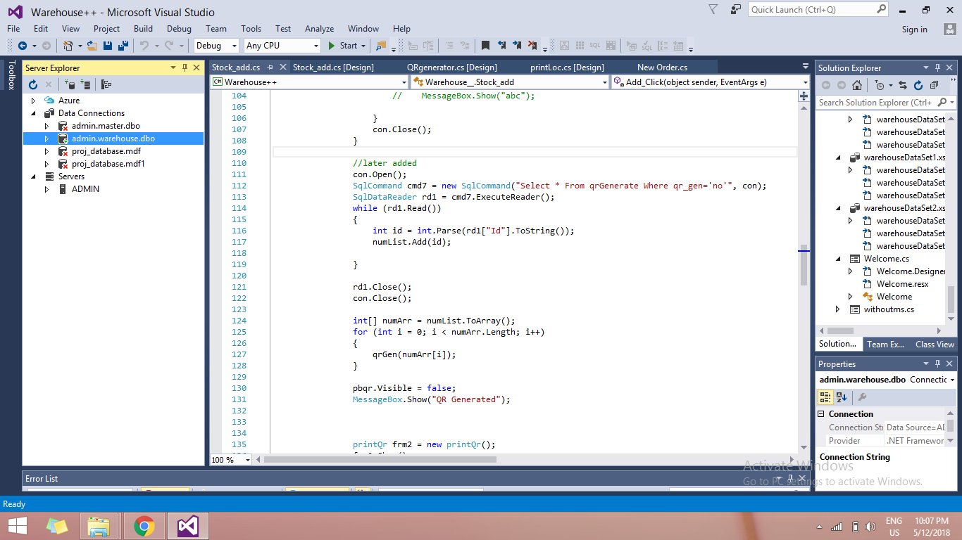

**Android Application :**

* Change the Gradle File Settings if Your Android Studio Version is different than specified in this document.
  + Reference link : https://youtu.be/AUWcAeBa91g
* Change the Following variables according to your database in ConnectionClass.Activity class.
  + String ip = "192.168.43.187";
  + String db = "warehouse"; //replace with your db name
  + String un = "shabnam1"; //replace with your user id and password in db.
  + String password = “12345”;

For ip, get the ip by entering ipconfig command in cmd.

**Note : For the Android Application to work and get connected to database, The computer having database and the Mobile phone with the Android App needs to be connected to the same WIFI.**

**Database :**